**From:** Wykoff, Randy <WYKOFF@mail.etsu.edu>  
**Sent:** Friday, November 13, 2020 4:49 PM  
**To:** Pfeiffer, Phillip E., IV <PHIL@mail.etsu.edu>; Young, Dara Catherine <YOUNGDC@mail.etsu.edu>  
**Cc:** Parker, Shayne Tyler <PARKERS@mail.etsu.edu>; Wilson, William <WILSONWE@mail.etsu.edu>; Spangler, Ethan <SPANGLERE@mail.etsu.edu>  
**Subject:** RE: Thank you again for your time

Phil—

Thanks to all of you for your continued dedication to this project!  I am more excited than ever that we will have a highly usable product.

As promised, here are some geographic areas we would like to pre-select:

1)       All of the 420 counties of Appalachia:  <https://www.arc.gov/appalachian-counties-served-by-arc/>

2)       The 238 counties and cities* of Central Appalachia

 ·         [**Kentucky**](https://www.arc.gov/kentucky/)**(54  counties):**Adair, Bath, Bell, Boyd, Breathitt, Carter, Casey, Clark, Clay, Clinton, Cumberland, Edmonson, Elliott, Estill, Fleming, Floyd, Garrard, Green, Greenup, Harlan, Hart, Jackson, Johnson, Knott, Knox, Laurel, Lawrence, Lee, Leslie, Letcher, Lewis, Lincoln, McCreary, Madison, Magoffin, Martin, Menifee, Metcalfe, Monroe, Montgomery, Morgan, Nicholas, Owsley, Perry, Pike, Powell, Pulaski, Robertson, Rockcastle, Rowan, Russell, Wayne, Whitley, and Wolfe

·         [**North Carolina**](https://www.arc.gov/north-carolina/)**(29 counties):**Alexander, Alleghany, Ashe, Avery, Buncombe, Burke, Caldwell, Cherokee, Clay, Davie, Forsyth, Graham, Haywood, Henderson, Jackson, McDowell, Macon, Madison, Mitchell, Polk, Rutherford, Stokes, Surry, Swain, Transylvania, Watauga, Wilkes, Yadkin, and Yancey

·         [**Ohio**](https://www.arc.gov/ohio/)**(19 counties):**Adams, Athens, Brown, Clermont, Gallia, Highland, Hocking, Jackson, Lawrence, Meigs, Monroe, Morgan, Noble, Perry, Pike, Ross, Scioto, Vinton, and Washington

·         [**Tennessee**](https://www.arc.gov/tennessee/)**(52  counties):**Anderson, Bledsoe, Blount, Bradley, Campbell, Cannon, Carter, Claiborne, Clay, Cocke, Coffee, Cumberland, De Kalb, Fentress, Franklin, Grainger, Greene, Grundy, Hamblen, Hamilton, Hancock, Hawkins, Jackson, Jefferson, Johnson, Knox, Lawrence, Lewis, Loudon, McMinn, Macon, Marion, Meigs, Monroe, Morgan, Overton, Pickett, Polk, Putnam, Rhea, Roane, Scott, Sequatchie, Sevier, Smith, Sullivan, Unicoi, Union, Van Buren, Warren, Washington, and White

·         [**Virginia**](https://www.arc.gov/virginia/)**(25 counties and 8 cities*):**Alleghany, Bath, Bland, Botetourt, Buchanan, Carroll, Craig, Dickenson, Floyd, Giles, Grayson, Henry, Highland, Lee, Montgomery, Patrick, Pulaski, Rockbridge, Russell, Scott, Smyth, Tazewell, Washington, Wise, and Wythe, and the cities of:  Bristol (Washington County), Buena Vista (Rockbridge County), Covington (Alleghany County), Galax (Carroll County), Lexington (Rockbridge County), Martinsville (Henry County), Norton (Wise County), and Radford (Montgomery County)

·         [**West Virginia**](https://www.arc.gov/west-virginia/)**(51 counties):**Barbour, Berkeley, Boone, Braxton, Cabell, Calhoun, Clay, Doddridge, Fayette, Gilmer, Grant, Greenbrier, Hampshire, Hardy, Harrison, Jackson, Jefferson, Kanawha, Lewis, Lincoln, Logan, Marion, Mason, McDowell, Mercer, Mineral, Mingo, Monongalia, Monroe, Morgan, Nicholas, Pendleton, Pleasants, Pocahontas, Preston, Putnam, Raleigh, Randolph, Ritchie, Roane, Summers, Taylor, Tucker, Tyler, Upshur, Wayne, Webster, Wetzel, Wirt, Wood, and Wyoming

*Virginia reports health data for its cities, separately than for its counties.  We should include these, as if they were distinct geographic regions.

3)       The 43 non-Appalachian Counties of Tennessee:  Bedford, Benton, Carroll, Cheatham, Chester, Crockett, Davidson, Decatur, Dickson, Dyer,  Fayette, Gibson, Giles, Hardeman, Hardin, Haywood, Henderson,  Henry, Hickman, Houston, Humphreys, Lake, Lauderdale, Lincoln, McNairy, Madison, Marshall, Maury, Montgomery, Moore, Obion, Perry, Robertson, Rutherford, Shelby, Stewart, Sumner, Tipton, Trousdale, Wayne, Weakley, Williamson, Wilson

4)      The Ballad Health Service Area:

a.       Tennessee:  Carter, Greene, Hancock, Hawkins, Johnson, Sullivan, Unicoi, Washington;

b.       Virginia:   Bland, Bristol City, Buchanan, Carroll, Galax City, Grayson, Norton City, Russell, Scott,  Smyth, Tazewell, Washington, Wise, Wythe

At some point in the future, we may add other “regions” but, for the moment these would be great (in addition to the States).

In terms of the metrics we would want to use, ideally, we would, eventually like to have as many as we could reasonably have.  However, as a starting point, from the County Health rankings, I would want:

1)      Adult Smoking

2)      Adult Obesity

3)      Children in Poverty

4)      Life Expectancy***

5)      Median Household Income*

6)      Some College

7)      Primary Care Physicians

If I could get more, I would add:

8)      Dentists

9)      Diabetes prevalence***

10)   Drug Overdose Deaths**

11)   Physical Inactivity

12)   Poor Mental Health Days

13)   Poor Physical Health Days

14)   Premature Death Rate

15)   Suicides*

16)   Uninsured

*this is included in the “Additional Social and Economic Factors”

**this is included in the “Additional Health Behaviors”

***this is included in “Additional Health Outcomes”

 Here is an example of the kind of images we would like to be able to create.  The solid line is Premature Death for all 3,141 counties in the United States.  The red dots (in this case) are the  55 counties in West Virginia:

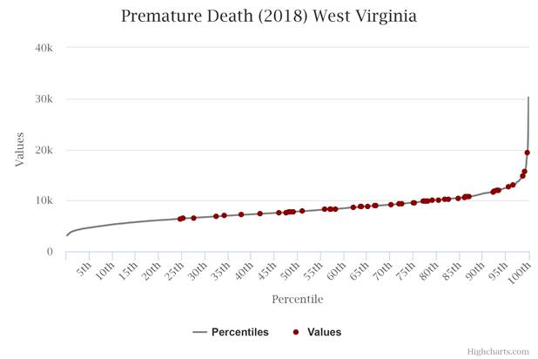

Many thanks!

--Randy

**Randy Wykoff, MD, MPH & TM**

Dean and Professor

College of Public Health

Director,

Center for Rural Health Research

ETSU Health